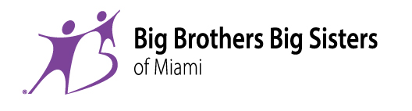
Carnival Center for Excellence
550 NW 42nd Avenue
Miami, FL 33126
Website: www.bbbsmiami.org
Tel: (305) 644-0066
Fax: (305) 847-2447
E-mail: volunteer@bbbsmiami.org
Dear Volunteer,

Thank you for your interest in getting involved with Big Brothers Big Sisters of Miami. We appreciate your willingness to help our kids. Please read the information below about our programs, requirements, and ways that you can help.

Program options to become involved with our organization:

· COMMUNITY-BASED PROGRAM: As a volunteer you will be paired with a young person (5-14) in a one-to-one relationship. You spend time together a minimum of twice per month based on your schedule and availability. Activities with your mentee should be focused on shared-interest activities, including educational or sports-themed activity or any other child-safe, parent-approved activity. For this program, you must have your own transportation, proof of driver’s license and a copy of your insurance card.

· BIGS IN SCHOOLS PROGRAM: As a volunteer you will be paired with a child at a nearby elementary school and meet for an hour or so each week during the school year. Visits take place during school hours or in the aftercare program from 2:30pm to 6:00pm. Activities with your mentee might include playing educational games, reading together, or just talking. You and your mentee are not permitted to leave the school premises at any time. We have programs in several elementary schools in Miami-Dade County. (A list of available schools can be viewed on our website at bbbsmiami.org.

· SCHOOL TO WORK PROGRAM: This program is for companies/organizations that would like to volunteer as a group. Employee mentors are paired with high school students who visit the volunteer mentor at their work site four hours monthly during the school year. Students gain valuable exposure to workplace practices and career opportunities. For more information on this program, please call the Big Brothers Big Sisters Community Partnerships Department at (305) 644-0066 or email us at: partnerships@bbbsmiami.org

To become a Mentor in any of our Programs, you must:

- Participate in a program of your choice for at least one calendar year. Research and our professional experience tell us that it takes one year to develop a positive friendship with your Mentee. Research has shown that matches that last less than 6 months can in fact have a negative impact on children.
- Be currently living or working in the Miami-Dade County area. Broward County volunteers are encouraged to participate with the Broward agency but are welcome to participate in our agency as long as they are willing to commute to Miami to meet with their Mentee.
- Complete the Volunteer Application.
- Set aside 2 hours for an interview and training session with an enrollment staff. (To schedule your interview please call us at: 305-644-0066
- If volunteering in the COMMUNITY-BASED PROGRAM: Please include your driver’s license information on the application and submit copies of your auto insurance and your driver’s license.
- If volunteering in the BIGS IN SCHOOLS PROGRAM or SCHOOL TO WORK PROGRAM: Please review the list of schools available in your area and the times they are open for visits.

We look forward to you volunteering with us! Please feel free to contact us at 305-644-0066 if you have any additional questions.

Sincerely,
Big Brothers Big Sisters Program Staff
Carnival Center for Excellence
550 NW 42nd Avenue
Miami, FL 33126
Website: www.bbbsmiami.org

Tel: (305) 644-0066
Fax: (305) 847-2447
Email: volunteer@bbbsmiami.org
VOLUNTEER APPLICATION

(Please FAX or EMAIL this application prior to your interview – or bring the COMPLETED application to your interview)
First Name: |  | Middle Name: |  |  | Last Name: |  |  |  |  | Date of Birth:  - -
Current Address: |  |  |  |  | City: |  |  | State:  FLORIDA |  |  |  | Zip:
Email: |  |  |  | Home Ph #:  ( ) - |  | Work Ph #:  ( ) - |  |  |  |  | Cell Ph #:  ( ) -
Gender:  Male Female | Social Security # (required):  - - |  |  |  | Ethnicity: |  |  |  | Marital Status:
Referral Source: |  |  | Occupation: |  |  |  | Level of Education:
Employer or School Name: |  |  |  |  | How Long Employed:  Years Months |  |  |  | Expected Graduation Date:  Month Year
Employment or School Address: |  |  |  |  | City: |  |  | State: |  |  |  | Zip:
Job Position: |  |  |  |  | Can We Contact You At Work:  Yes No |  |  |  |  | Best Time To Call:
Do you have a driver’s license?  Yes No |  | State of Issue: |  |  | Driver’s License #: |  |  |  |  | Expiration date:  - -
Have you ever applied to be a Big Brother or Big Sister?  Yes No |  |  |  |  | Where: |  |  |  |  | When:
Emergency Contact: |  |  |  |  | Phone: |  |  |  |  | Relationship to applicant:
At this time, which of our programs are you most interested in?
Community School School to Work Other _________________________________

I understand that:
- The references I list may be contacted in-person or by mail, telephone, or email.
- This application in no way obligates me to perform any volunteer services.
- The information I provide may be used to conduct a background check, driving record check and/or any other information required by local, state, or federal law for volunteers working with youth.
- I understand that BBBS will conduct subsequent background screenings to ensure child safety
- BBBS is not obligated to match me with a youth.
- As part of the enrollment process, I will be asked to provide additional personal information prior to receiving any recommendations for assignment.
- Proof of a DRIVER’S LICENSE AND COPY OF AUTO INSURANCE is required to participate in the COMMUNITY-BASED PROGRAM. Digital signatures can’t be accepted from driver’s license carriers of AR, CA, CO, GA, MD, MA, NH or WA.

________________________________________ _________/_________/__________
Signature (Handwritten or Digital Only) (Date)

If applicable, please denote your maiden (birth) name: __________________________________
Page 1 (Continue to Page 2 to complete references)
REFERENCES
Please provide the following information for your references:
- Spouse or live in boyfriend/girlfriend required if applicable
- A close family member who has known you at least 3 years
- Your current or past employer who has known you at least 1 year
- Personal friend who has known you at least 2 years
- Personal friend who has known you at least 2 years
- Previous Youth Experience required if applicable

APPLICANT NAME

___________________________________

1. Spouse or live in boyfriend/girlfriend (required if applicable): | First Name: | Last Name:
Day Phone #:  ( ) - | Email:
2. Close family member who has known you for at least 3  years: | First Name: | Last Name:
Day Phone #:  ( ) - | Email:
3. Coworker (or teacher if a student) who has known  you at least 1 year: | First Name: | Last Name:
Day Phone #:  ( ) - | Email:
4. Personal friend who has known you at least 2  years: | First Name: | Last Name:
Day Phone #:  ( ) - | Email:
5. Personal friend who has known you at least  2 years: | First Name: | Last Name:
Day Phone #:  ( ) - | Email:
6. If you have worked or volunteered with children  or youth within the past 5 years (required): | First Name: | Last Name:
 | Agency/Organization Name:
Day Phone #:  ( ) - | Email:
Address:

WAIVER

I, _______________________________ , hereby waive any privacy or other privilege I might have and authorize the State of Florida Department of Law Enforcement to search criminal records, and if there are any entries therein to copy such and deliver copies of any such entries or other references to Big Brothers Big Sisters of Greater Miami. This waiver is executed with full knowledge and understanding that the information is for the use of Big Brothers Big Sisters of Greater Miami in evaluating my application for membership in the organization, particularly my worthiness of character as an influence on young persons I may come into contact with as a member of that organization.

________________________________ _________/_________/__________ Signature (Handwritten or Digital Only) (Date)

Page 2
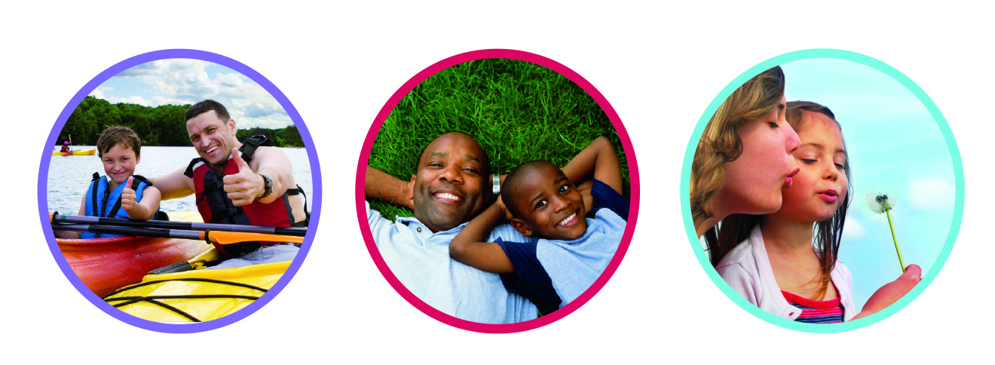
Carnival Center for Excellence
550 NW 42nd Avenue
Miami, FL 33126
Website: www.bbbsmiami.org

Tel: (305) 644-0066
Fax: (305) 847-2447
Email: volunteer@bbbsmiami.org

THE “BIG” GIVEBACK PROGRAM

The BIG Giveback Program is designed for Big Brothers and Big Sisters to give back to Big Brothers Big Sisters of Miami! When you support BBBS, your contributions will create sustainable matches and assist with administrative and processing costs.

BIGS CARE…Join the BIG Giveback Movement and change a life forever.

You can make a contribution in one of the following ways:

I would like to give $50 to help with the cost of my background check. | I would like to give $100 to help with my background check and administrative/processing costs.
I would like to become a sustainable Match Maker with a monthly gift of $19.95 | No thank you. I am excited about being a volunteer.
Big Brothers Big Sisters of Miami is a tax-exempt 501(c) (3) charitable organization.
Check Information  Check Number: __________________________  Check Amount: $ ______________  Please make checks payable to: Big Brothers Big Sisters | Credit Card Information  Credit Card Number:  ___________________________________________________  Expiration: ________ / _________ CVV2: _________
BILLING INFORMATION
Name as printed on Credit Card: _______________________________________________________________________________

Billing Address: _____________________________________________________________________________________________

City: ________________________________ State: ________________________________ Zip Code: ________________________

Phone: (______) ________ -________ Email: _____________________________________________________________________

Signature: ____________________________________
Signature (Handwritten or Digital Only)

You can also make this contribution online on our secure website at www.bbbsmiami.org or click if using this form electronically. Please designate your contribution as Application in the comments section.

Received by: ________________________ __________________________
BBBS Staff Name BBBS Staff Signature

